# S 255 System Design Document Template

This template lays out all the different sections that you need to complete for Project Two. Each section has guidance to prompt your thinking. You will need to continually reference the interview transcript as you work to make sure that you are addressing your client’s needs. There is no required length for the final document. Instead the goal is to complete each section based on what your client’s needs are. Remove this note when you are finished, and replace all bracketed text with the relevant information.

## UML Diagrams

### UML Use Case Diagram

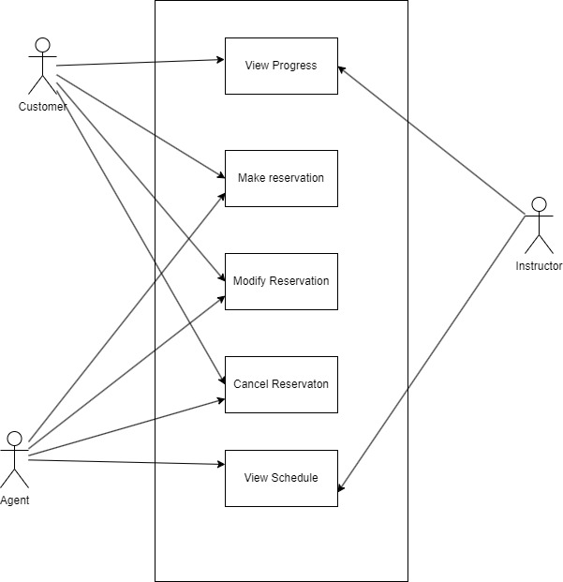

### UML Activity Diagrams

Login Activity

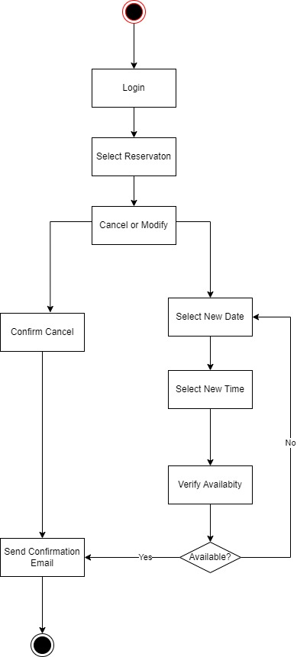

### UML Sequence Diagram

### UML Class Diagram

## Technical Requirements

*Based on these diagrams we will need access to a web server in order for the application to function. When this application is written we should probably use a REST API for communication between the clients and the servers. That being said I think a Client/Server model would work the best when it comes to architecture of the application.*